POC 01 – Serverless CRUD API Using AWS Lambda, API Gateway & DynamoDB

- Document Information
Field | Details
POC Name | Serverless CRUD Notes API
Author | Dhivyalakshmi B
Date | 11/12/2025
Version | 1.0
Reviewed by

2. Objective
This POC demonstrates how to build a fully serverless CRUD API using:
- Amazon API Gateway
- AWS Lambda (Python)
- Amazon DynamoDB
- IAM Roles & CloudWatch Logs
The goal is to provide a scalable, cost-efficient backend API without managing servers, suitable for microservices, automation, or internal tooling.
3. High-Level Architecture
Architecture Diagram
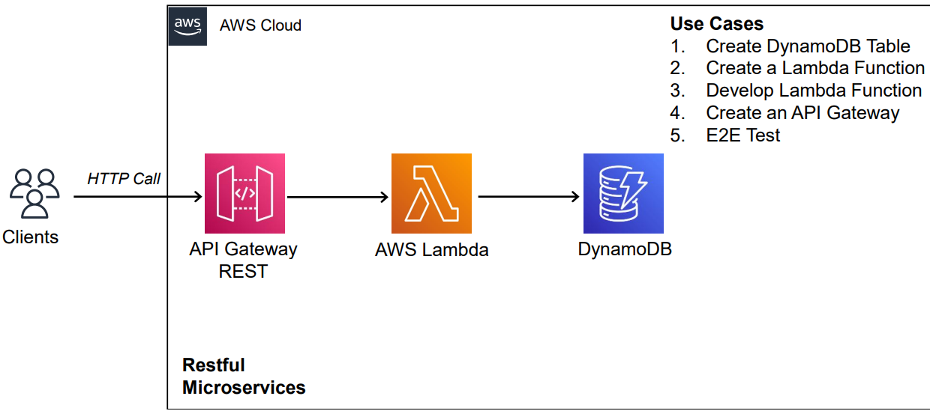

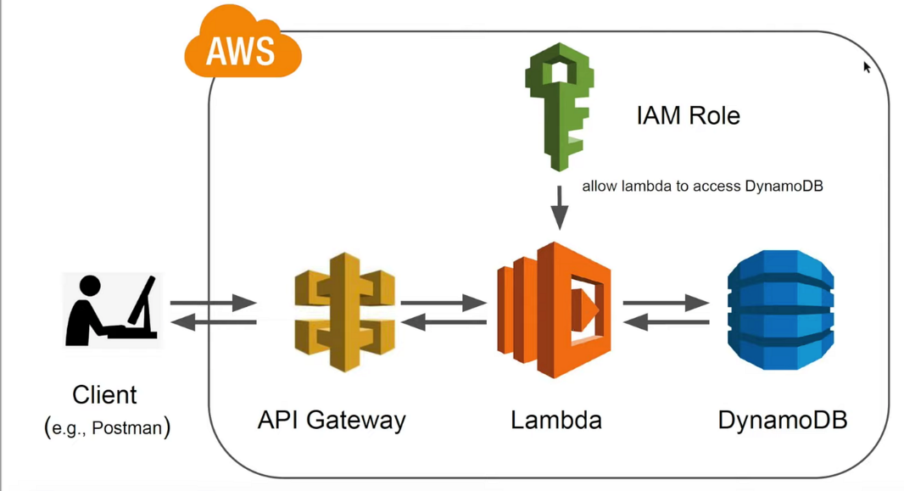
Client (Postman) → API Gateway → Lambda Function → DynamoDB Table → Lambda → API Gateway → Client

Key AWS Services Used:
Service | Purpose
API Gateway | Public API routing, HTTP interface
Lambda (Python) | Backend business logic
Dynamo DB | NoSQL data storage
IAM | Security & access control
CloudWatch | Logging & debugging

4. Detailed Implementation Steps
4.1 DynamoDB Setup
Table Name: ItemsTable
Primary Key: id (String)
Steps:
- Open DynamoDB → Create Table
- Enter table name: ItemsTable
- Partition Key: id (String)
- Keep all default settings → Create
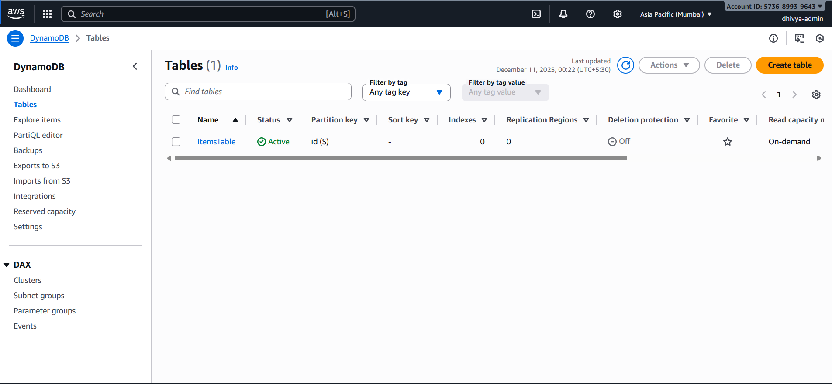
4.2 IAM Role Setup
Role: lambda-dynamodb-crud-role
Policies Attached:
- AWSLambdaBasicExecutionRole
- AmazonDynamoDBFullAccess (POC only; can be restricted later)

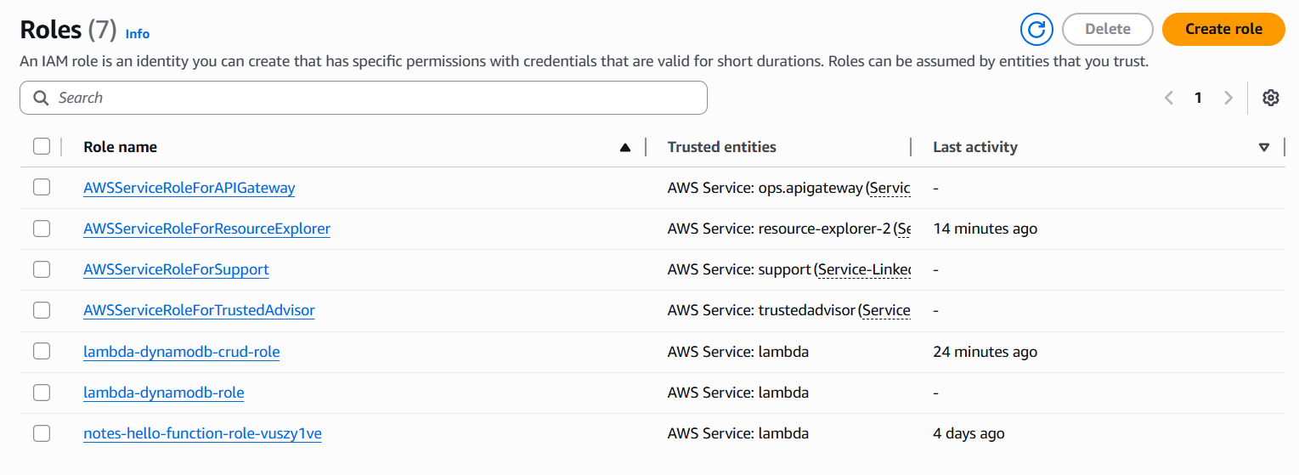
4.3 Lambda Function Setup
Function Name: items-crud-function
Runtime: Python 3.x
Execution Role: lambda-dynamodb-crud-role
Steps:
- Go to Lambda → Create Function → Author from Scratch
- Name: items-crud-function
- Runtime: Python 3.x
- Choose existing role → lambda-dynamodb-crud-role
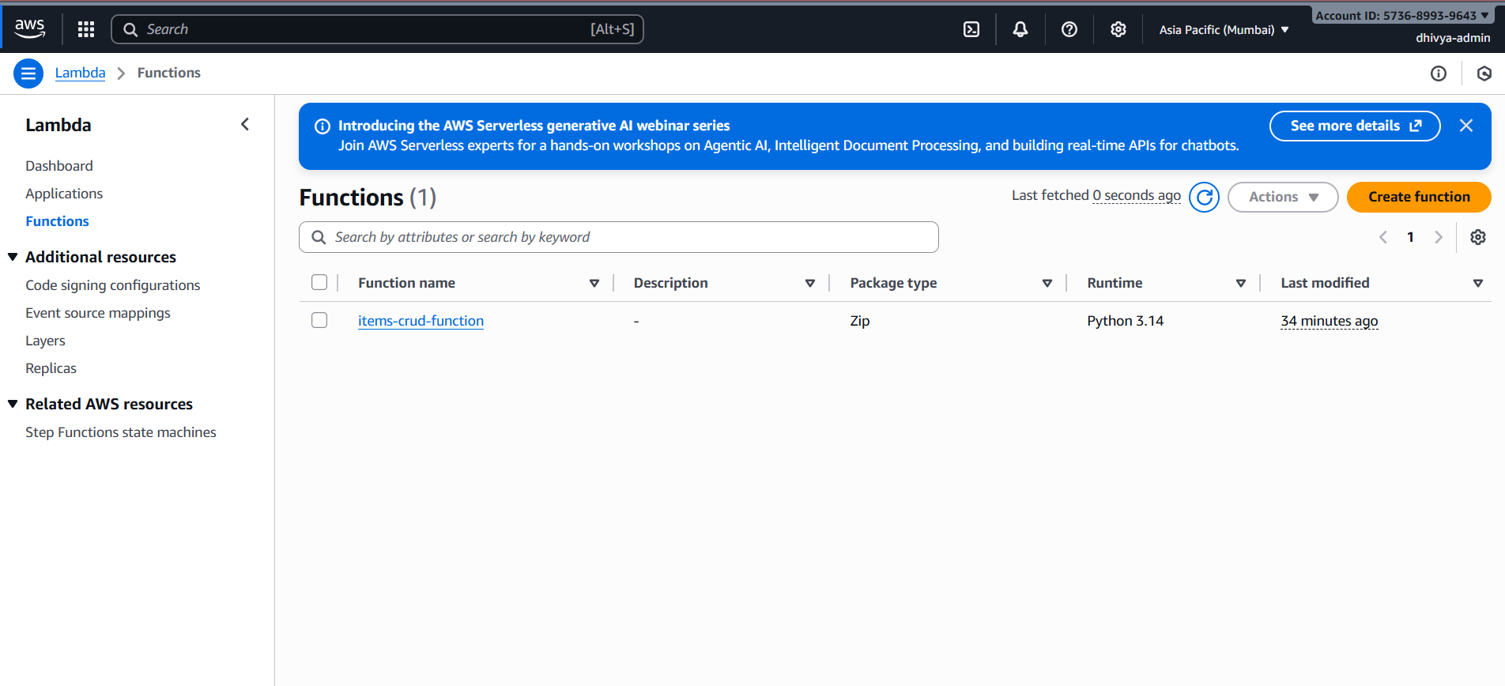

4.4 Lambda Code (CRUD Logic):
import json
import boto3

# Connect to DynamoDB
dynamodb = boto3.resource('dynamodb')
table = dynamodb.Table('ItemsTable') # Make sure this matches your table name

# Helper to format HTTP responses
def response(status_code, body):
return {
"statusCode": status_code,
"headers": {
"Content-Type": "application/json",
"Access-Control-Allow-Origin": "*"
},
"body": json.dumps(body)
}

def lambda_handler(event, context):
# 1) Read HTTP method (GET, POST, etc.)
http_method = event.get("httpMethod")

# 2) Read path (like /Dev/items or /Dev/items/1)
path = event.get("path", "")

# 3) Read path parameters (like { "id": "1" } for /items/1)
path_params = event.get("pathParameters") or {}

# 4) Read body (for POST/PUT). It will be a JSON string.
raw_body = event.get("body")
body = None
if raw_body:
try:
body = json.loads(raw_body)
except json.JSONDecodeError:
return response(400, {"message": "Invalid JSON body"})

# CREATE: POST /items
if http_method == "POST" and path.endswith("/items"):
if not body or "id" not in body:
return response(400, {"message": "Field 'id' is required in body"})

table.put_item(Item=body)

return response(201, {
"message": "Item created successfully",
"item": body
})

# READ: GET /items/{id}
if http_method == "GET" and path_params.get("id"):
item_id = path_params["id"] # example: "1"

result = table.get_item(Key={"id": item_id})
item = result.get("Item")

if not item:
return response(404, {"message": "Item not found"})

return response(200, item)

# UPDATE: PUT /items/{id}
if http_method == "PUT" and path_params.get("id"):
item_id = path_params["id"]

if not body:
return response(400, {"message": "Request body is required for update"})

body["id"] = item_id # force id from path

table.put_item(Item=body)

return response(200, {
"message": "Item updated successfully",
"item": body
})

# DELETE: DELETE /items/{id}
if http_method == "DELETE" and path_params.get("id"):
item_id = path_params["id"]

table.delete_item(Key={"id": item_id})

return response(200, {
"message": f"Item with id {item_id} deleted successfully"
})

# other methods/paths not handled
return response(400, {
"message": "No handler for this method/path",
"http_method": http_method,
"path": path,
"path_params": path_params,
"body": body
})

4.5 API Gateway Setup:
Resource | Methods | Connected To
/items | POST | Lambda Proxy
/items/{id} | GET,PUT,DELETE | Lambda Proxy

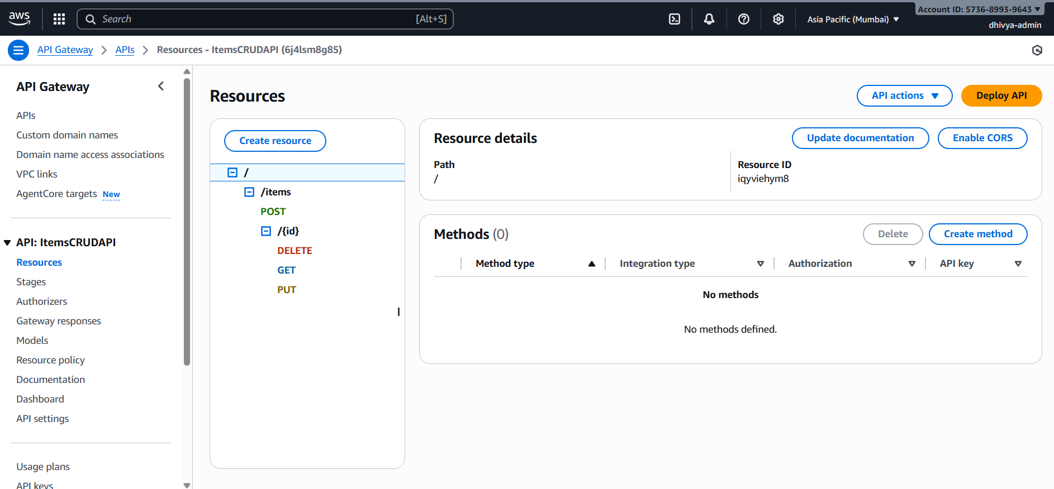
4.6 Deployment
- Stage Name: Dev
- Invoke URL: https://6j4lsm8g85.execute-api.ap-south-1.amazonaws.com/Dev
5.Testing (Postman Web)
POST /items
Body:
{
"id": "1",
"name": "Postman Item",
"description": "Created from Postman Web"
}
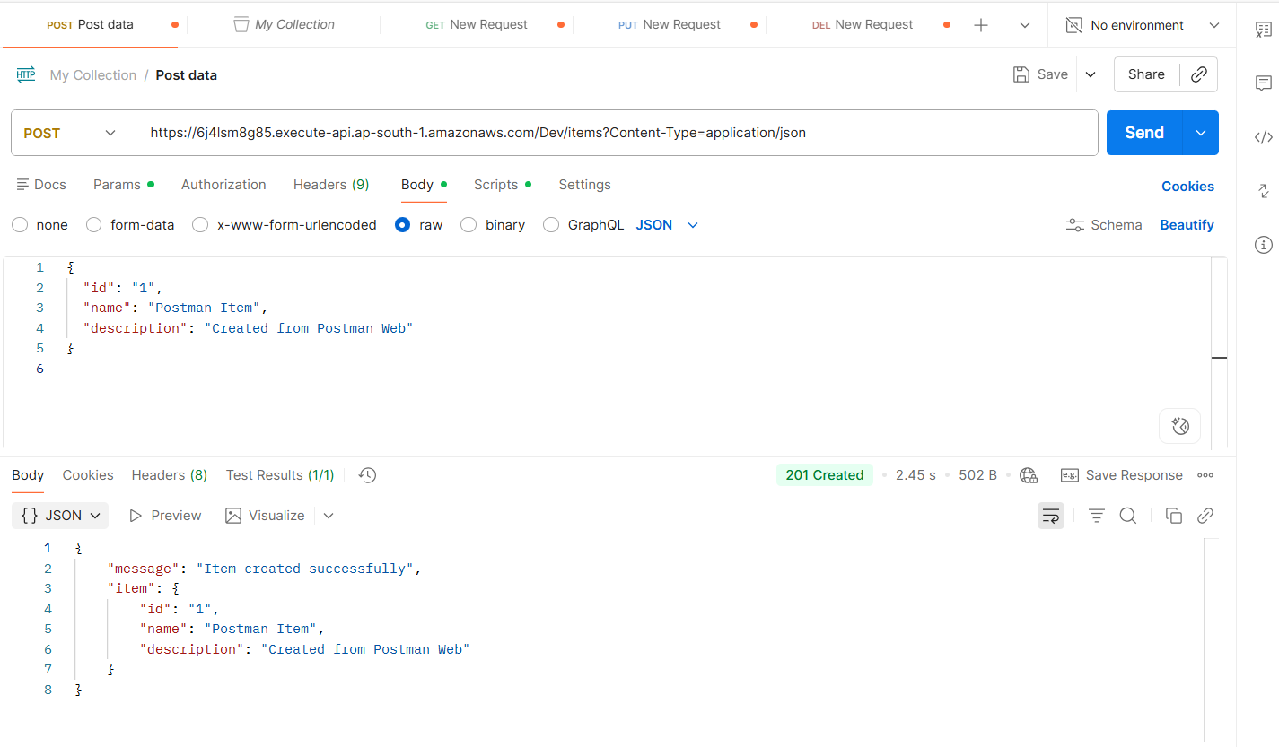
GET /items/1
Returns the created item.
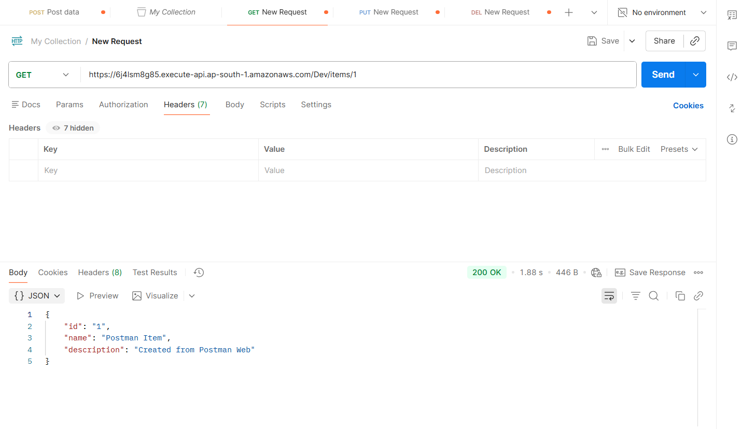
PUT /items/1
Updates item fields.
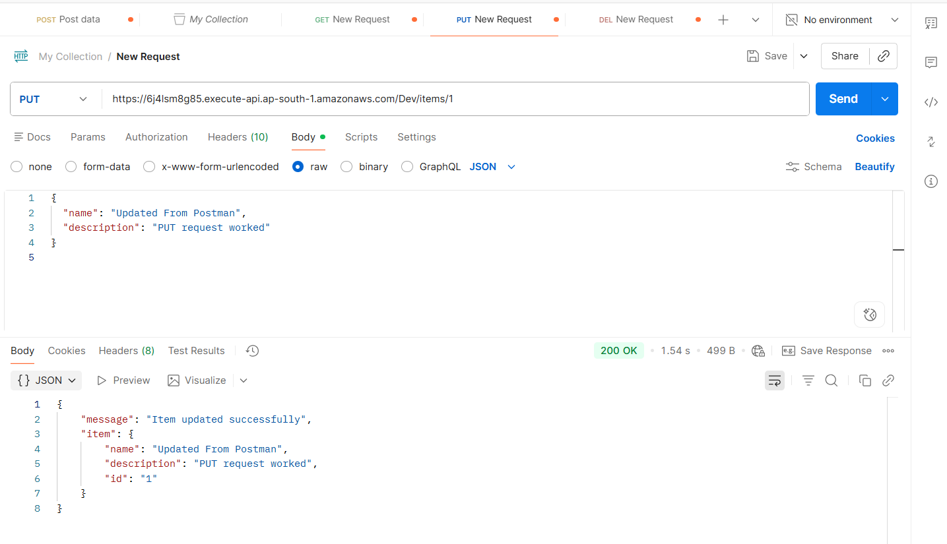
DELETE /items/1
Deletes the item.
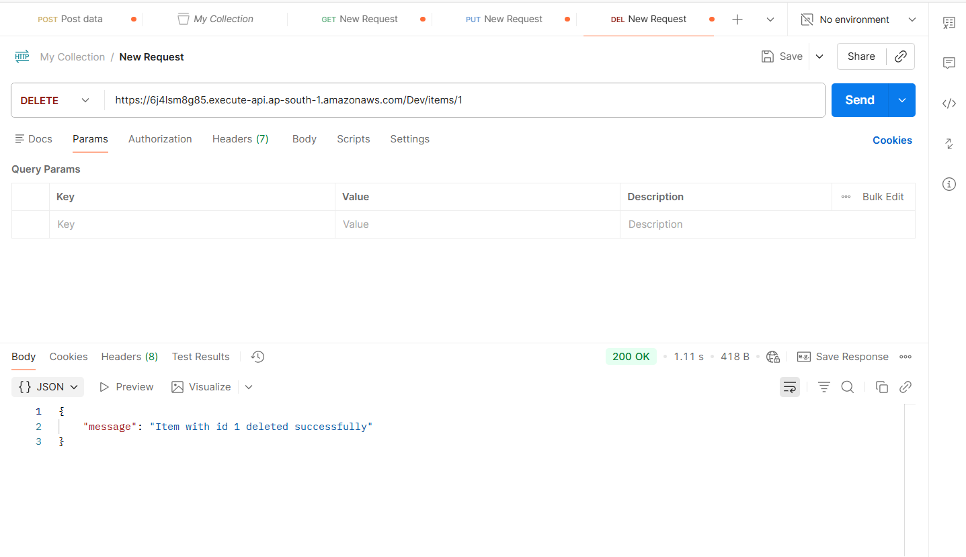

6. Error Handling & Debugging
We encountered and fixed:
- 502 Bad Gateway
  - Cause: Python error inside Lambda
  - Fix: CloudWatch logs → corrected path_params("id") to path_params.get("id")
- Internal Server Error during GET
  - Cause: Calling dictionary incorrectly
  - Fix: Corrected code and redeployed Lambda
7. Final Outcome
This POC demonstrates:
- End-to-end serverless architecture
- Full CRUD API working over HTTP
- Lambda + DynamoDB integration
- External testing via Postman
- Real-time debugging workflow
- Error-handling improvements
The system is scalable, low-cost, and ideal for microservices or automation workflows.

